Insta cart data dictionary

Link: <https://gist.github.com/jeremystan/c3b39d947d9b88b3ccff3147dbcf6c6b#file-data_description-md>

Citation: The Instacart Online Grocery Shopping Dataset 2017”, Accessed from www.instacart.com/datasets/grocery-shopping-2017 via Kaggle on

1. order_id: order identifier
2. user_id: customer identifier
3. eval_set: which evaluation set this order belongs in (see SET described below)
4. order_number: the order sequence number for this user (1 = first, n = nth)
5. order_dow: the day of the week the order was placed on
6. order_hour_of_day: the hour of the day the order was placed on
7. days_since_prior: days since the last order, capped at 30 (with NAs for order_number = 1)

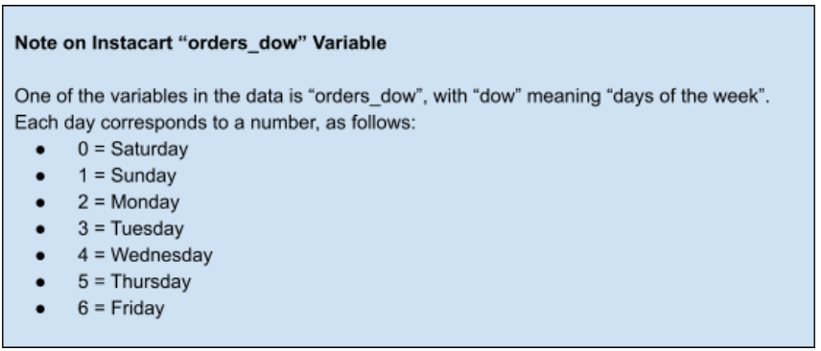

products (50k rows):

* product_id: product identifier
* product_name: name of the product
* aisle_id: foreign key
* department_id: foreign key

aisles (134 rows):

* aisle_id: aisle identifier
* aisle: the name of the aisle

deptartments (21 rows):

* department_id: department identifier
* department: the name of the department

order_products__SET (30m+ rows):

* order_id: foreign key
* product_id: foreign key
* add_to_cart_order: order in which each product was added to cart
* reordered: 1 if this product has been ordered by this user in the past, 0 otherwise

where SET is one of the four following evaluation sets (eval_set in orders):

* "prior": orders prior to that users most recent order (~3.2m orders)
* "train": training data supplied to participants (~131k orders)
* "test": test data reserved for machine learning competitions (~75k orders)